Final Project Proposal
Group：曾聖堯、蔡欣穎、賴岂廷、潘佳成、胡益嘉

- INTRODUCTION
With advances in computer vision, facial expression recognition is becoming a key technology for future intelligent systems. This study applies deep learning to build a model that identifies human emotions from images, aiming to improve recognition accuracy and support applications such as emotion monitoring, driver-fatigue detection, and adaptive human–machine interaction.
- RELATED WORKS
[1] proposed a lightweight CNN combined with face-cropping, small-angle rotation, alignment, and background removal to enhance facial expression recognition on small datasets. Their two-layer CNN achieved over 97% accuracy on CK+ and JAFFE, showing that proper preprocessing can significantly boost CNN performance.[2] introduced a hybrid GF-CNN model that integrates Gabor filters with CNNs to better capture texture and edge information. Achieving 99.85% accuracy on CK+48, this method outperformed traditional CNNs and other fusion approaches such as LBP-CNN and HOG-CNN.N.
- APPROACH
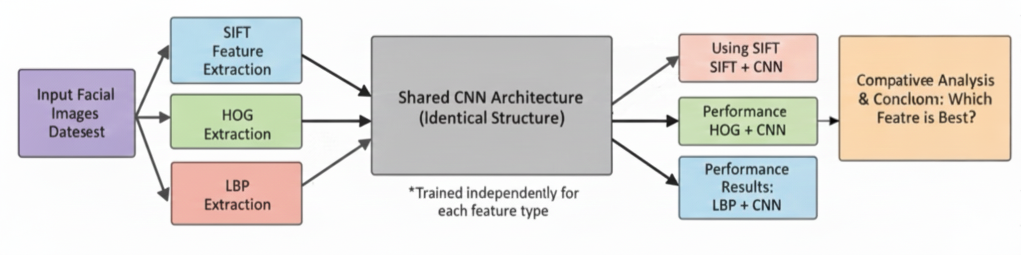
In this project, we apply several techniques to process the facial images, including feature extraction and the Gabor filter, and then pass these processed data to a CNN model to compare their results. We plan to use SIFT, HOG, and Gabor as three feature representations. SIFT detects keypoints and computes local descriptors that capture distinctive facial structures; these descriptors are then encoded into fixed-length vectors. HOG computes histograms of oriented gradients over local regions to emphasize edges and shape changes around key areas such as the eyes and mouth. Gabor Filter encodes local texture and structural information by applying a set of linear filters with varying scales and orientations. This emphasizes frequency and directionality, which are crucial for capturing the fine details of facial expression movements and skin texture, while offering robustness against illumination changes.
In our implementation, we will first load and preprocess the dataset, then apply each of the three data processing methods to generate corresponding feature vectors. These feature vectors will be reshaped or normalized as needed and fed into the same CNN architecture for training and evaluation. By keeping the CNN structure fixed and varying only the input features, we can directly compare how different data preprocessing techniques influence the final emotion recognition performance.
- EXPECTED RESULTS
Our goal is to develop a robust facial emotion recognition model capable of accurately classifying multiple human emotions, including Happy, Sad, Angry, Fear, and Surprise. By utilizing a large-scale labeled dataset and integrating feature extraction techniques with an improved deep learning architecture, we will evaluate the model using precision-recall curves, F1 score, accuracy, and confusion matrices as the primary evaluation metrics. Ultimately, we expect the model to achieve strong classification performance across all emotion categories.
- REFERENCES
[1] Li, K., Jin, Y., Akram, M. W., Han, R., & Chen, J. (2020). Facial expression recognition with convolutional neural networks via a new face cropping and rotation strategy. The visual computer, 36(2), 391-404.
[2] Deepan, P., Vidya, R., Reddy, M. A., Arul, N., Ravichandran, J., & Dhiravidaselvi, S. (2024). A hybrid Gabor filter-convolutional neural networks model for facial emotion recognition system. Indian Journal of Science and Technology, 17(35), 3696-3703.
- WORK ALLOCATION
Member | Tasks | Contribution
蔡欣穎 | Training, data analysis | 20%
曾聖堯 | Algorithm, model tuning | 20%
賴岂廷 | Data collection, training | 20%
潘佳成 | Report, Presentation | 20%
胡益嘉 | Proposal, data visualize | 20%

